Single Star

Code:

#include <GL/gl.h>

#include <GL/glut.h>

void display(void)

{

glClear (GL_COLOR_BUFFER_BIT);

glColor3f (1.0, 0.0, 0.0);

glBegin(GL_POLYGON);

glVertex2f(0.3, 0.3);

glVertex2f(0.4, 0.0);

glVertex2f(0.5, 0.3);

glVertex2f(0.8, 0.4);

glVertex2f(0.5, 0.5);

glVertex2f(0.4, 0.8);

glVertex2f(0.3, 0.5);

glVertex2f(0.0, 0.4);

glEnd();

glFlush ();

}

void init (void)

{

glClearColor (0.0, 0.0, 0.0, 0.0);

glMatrixMode(GL_PROJECTION);

glLoadIdentity();

//glOrtho(0.0, 1.0, 0.0, 1.0, -1.0, 1.0);

}

int main(int argc, char** argv)

{

glutInit(&argc, argv);

glutInitDisplayMode (GLUT_SINGLE | GLUT_RGB);

glutInitWindowSize (500, 500);

glutInitWindowPosition (100, 100);

glutCreateWindow ("Rony Single Star");

init ();

glutDisplayFunc(display);

glutMainLoop();

return 0;

}

Figure:

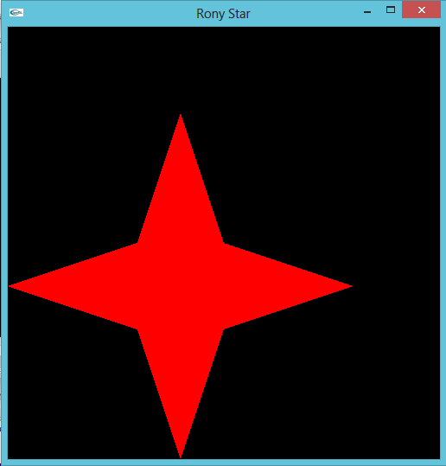

Multiple Star

Code:

#include <GL/gl.h>

#include <GL/glut.h>

void display(void)

{

glClear (GL_COLOR_BUFFER_BIT);

glColor3f (1.0, 0.0, 0.0);

glBegin(GL_POLYGON);

glVertex2f(0.1, 0.2);

glVertex2f(0.3, 0.3);

glVertex2f(0.1, 0.4);

glVertex2f(0.0, 0.6);

glVertex2f(-0.1, 0.4);

glVertex2f(-0.3, 0.3);

glVertex2f(-0.1, 0.2);

glVertex2f(0.0, 0.0);

glEnd();

glFlush ();

//glColor3f (0.0, 1.0, 0.0);

glColor3f (1.0, 0.0, 0.0);

glBegin(GL_POLYGON);

glVertex2f(0.2, -0.1);

glVertex2f(0.3, -0.3);

glVertex2f(0.4, -0.1);

glVertex2f(0.6, 0.0);

glVertex2f(0.4, 0.1);

glVertex2f(0.3, 0.3);

glVertex2f(0.2, 0.1);

glVertex2f(0.0, 0.0);

glEnd();

glFlush ();

//glColor3f (0.0, 0.0, 1.0);

glColor3f (1.0, 0.0, 0.0);

glBegin(GL_POLYGON);

glVertex2f(-0.1, -0.2);

glVertex2f(-0.3, -0.3);

glVertex2f(-0.1, -0.4);

glVertex2f(0.0, -0.6);

glVertex2f(0.1, -0.4);

glVertex2f(0.3, -0.3);

glVertex2f(0.1, -0.2);

glVertex2f(0.0, 0.0);

glEnd();

glFlush ();

//glColor3f (1.0, 0.0, 1.0);

glColor3f (1.0, 0.0, 0.0);

glBegin(GL_POLYGON);

glVertex2f(-0.2, 0.1);

glVertex2f(-0.3, 0.3);

glVertex2f(-0.4, 0.1);

glVertex2f(-0.6, 0.0);

glVertex2f(-0.4, -0.1);

glVertex2f(-0.3, -0.3);

glVertex2f(-0.2, -0.1);

glVertex2f(0.0, 0.0);

glEnd();

glFlush ();

}

void init (void)

{

glClearColor (0.0, 0.0, 0.0, 0.0);

glMatrixMode(GL_PROJECTION);

glLoadIdentity();

//glOrtho(0.0, 1.0, 0.0, 1.0, -1.0, 1.0);

}

int main(int argc, char** argv)

{

glutInit(&argc, argv);

glutInitDisplayMode (GLUT_SINGLE | GLUT_RGB);

glutInitWindowSize (500, 500);

glutInitWindowPosition (100, 100);

glutCreateWindow ("Rony Multiple Star");

init ();

glutDisplayFunc(display);

glutMainLoop();

return 0;

}

Figure:

